Tenda F3--How to change your SSID and password

Step 1: Login the homepage.
- Open a browser then type “192.168.0.1” into the Address Bar, press Enter. Then enter the password of this page. Tap “Login”.

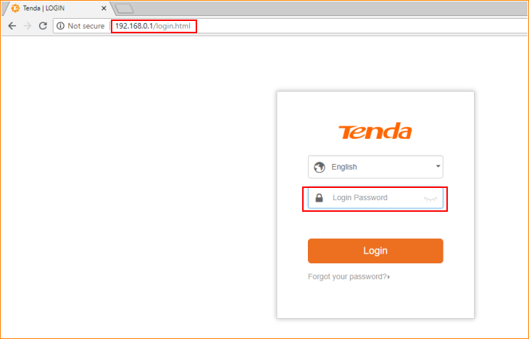

Note: The default password is shown on the bottom of the router. If you have changed it and you also forgot it, see “Forget your password?” below the “Login” button.

- Then the interface will turn into the homepage, tap “Wireless Settings”, change your SSID and password in this page, and tap “OK”.

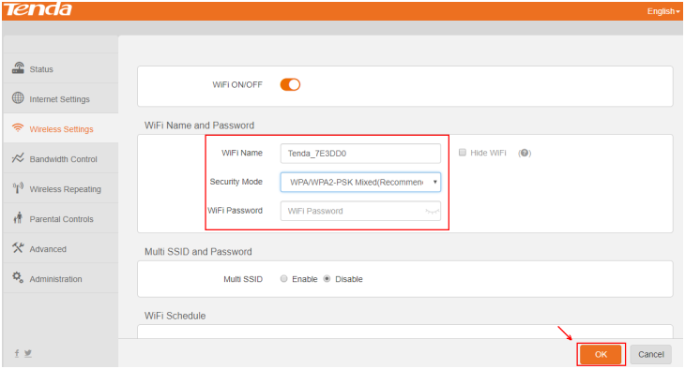

Note: For Security Mode, the WPA/WPA2-PSK is recommended.

- The notice window would be shown on the top. Tap “OK” and you will be disconnected with your Wi-Fi. Wait for 30 seconds, and connect with your router by connecting to the new SSID and password you set before.

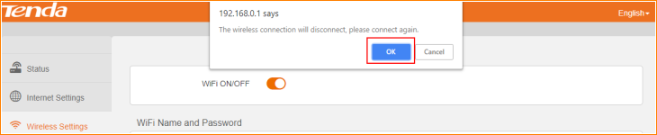

NOTE: If you forget your password you just set before, you can reset the router into factory setting and configure your password again.

